This guide will explain in simple easy steps how to write a referral letter from a patients record.

* Open the patients record
* Find referrals on the clinical tree and right click.

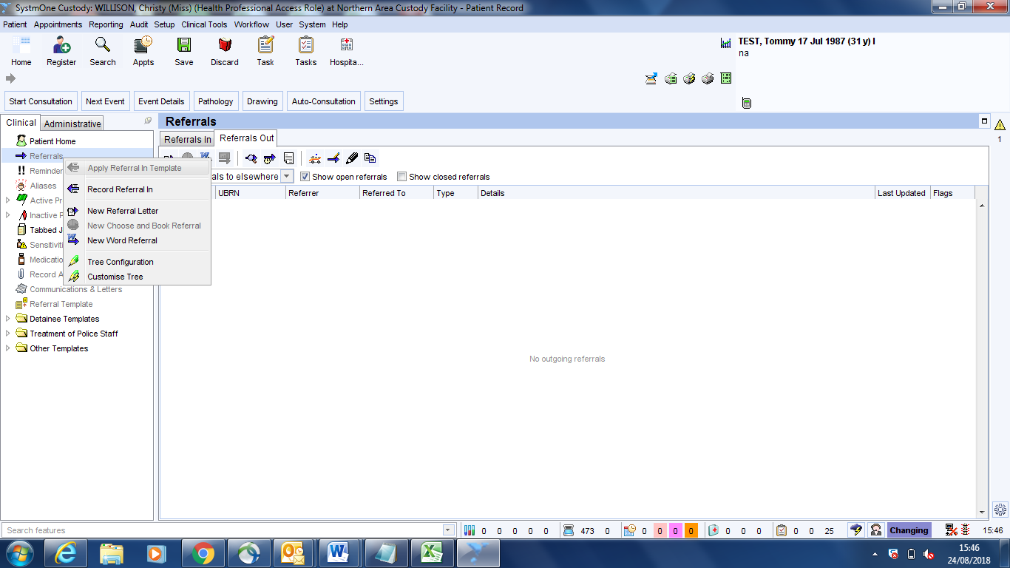

* Select the ‘New word referral’ option
* The following dialog box will appear

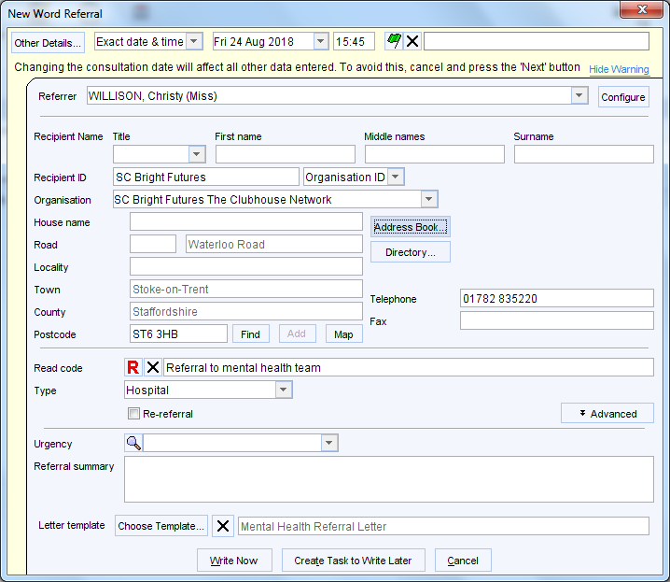

* Select address book and choose the relevant address book entry. This will then automatically read code the referral and choose the correct letter template (as shown above)
* You can the select ‘Write Now’
* A prepopulated word document will open that you will be able to fill in and then print off

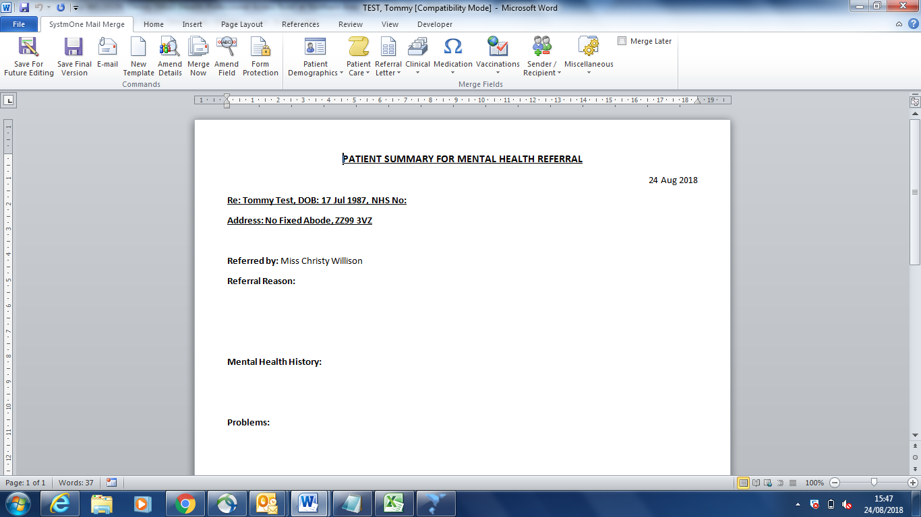

* If needed you can pull information through from the patients record using the merge field options.
* Once you have finished writing your letter you can select one of the two ‘Save’ options.
* Save for future editing; this will let you come back and amend the letter at a later stage.
* Save final version; this will be the final version of the letter and cant be amended after.